📖 NarrativeFlow

UI Design Document
Interactive Story Co-Writer

Prepared by: Ramya Jayaram
Prepared for: Infosys Springboard Virtual Internship
Platform: Streamlit (Python)
Date: 17th February 2026

Contents
1. Project Overview
2. Application Screens
3. Screen 1 – Authentication
4. Screen 2 – Dashboard
5. Screen 3 – Co-Writing Workspace
6. Streamlit Integration
7. Errors Encountered
8. Corrections Implemented
9. Feedback and Improvements
10. Learning Outcomes
11. Overall Experience

1. Project Overview
NarrativeFlow is a Python-based web application built with Streamlit that lets users co-write stories alongside an AI language model. The app follows a three-screen flow — login, story dashboard, and writing workspace — and stores all stories in a local SQLite database so they persist between sessions.

Key Features
- Secure login and sign-up with password hashing
- Personal story library stored in SQLite database
- Chat-style co-writing with three AI modes: Continue Sentence, Add Paragraph, and Smart Choice
- Configurable genre and tone settings per story
- One-click export to a formatted Microsoft Word document
- Support for multiple AI backends: Ollama (free/local), OpenAI, Claude, and Hugging Face

Technology Stack
The application is written entirely in Python. Streamlit handles the frontend and server. python-docx generates the Word export. SQLite stores users and stories. The AI layer is configurable — Ollama (LLaMA2) runs locally for free, while OpenAI and Claude are cloud API options.

2. Application Screens
NarrativeFlow has three screens. Routing between them is controlled by two session variables: authenticated and current_view. The logic lives entirely in app.py.
When the app loads, it checks whether the user is logged in. If not, the Authentication screen is shown. After login, the Dashboard is displayed. Clicking any story — or creating a new one — opens the Co-Writing Workspace. The user can navigate back to the Dashboard at any time without losing their work.

File Structure
The project is split into seven files, each with a single responsibility: app.py (routing), auth.py (login/signup), dashboard.py (story list), workspace.py (AI writing), database.py (SQLite), utils.py (session setup), and styles.py (custom CSS).
3. Screen 1 – Authentication
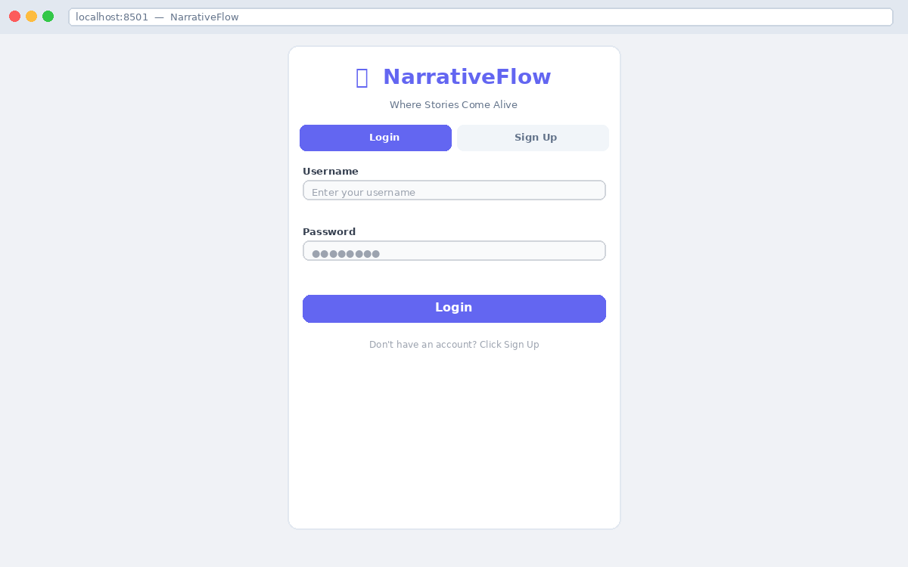
Authentication screen with Login tab active
The Authentication screen is the entry point for all users. The form is centred on the page using a three-column layout, keeping the interface focused and clean. Two tabs — Login and Sign Up — switch between forms without a page reload.

Login
The user enters a username and password. The password is hashed using SHA-256 and compared against the stored hash in the database. Any mismatch shows a clear error message inline.
Sign Up
The registration form collects a username, optional email, password, and a confirmation field. Validation checks that the password is at least six characters, both password fields match, and the username is not already taken.
Validation Rules
- Username and password must not be empty
- Password minimum length: 6 characters (Sign Up only)
- Password and Confirm Password must match
- Username must be unique — enforced by the database
4. Screen 2 – Dashboard
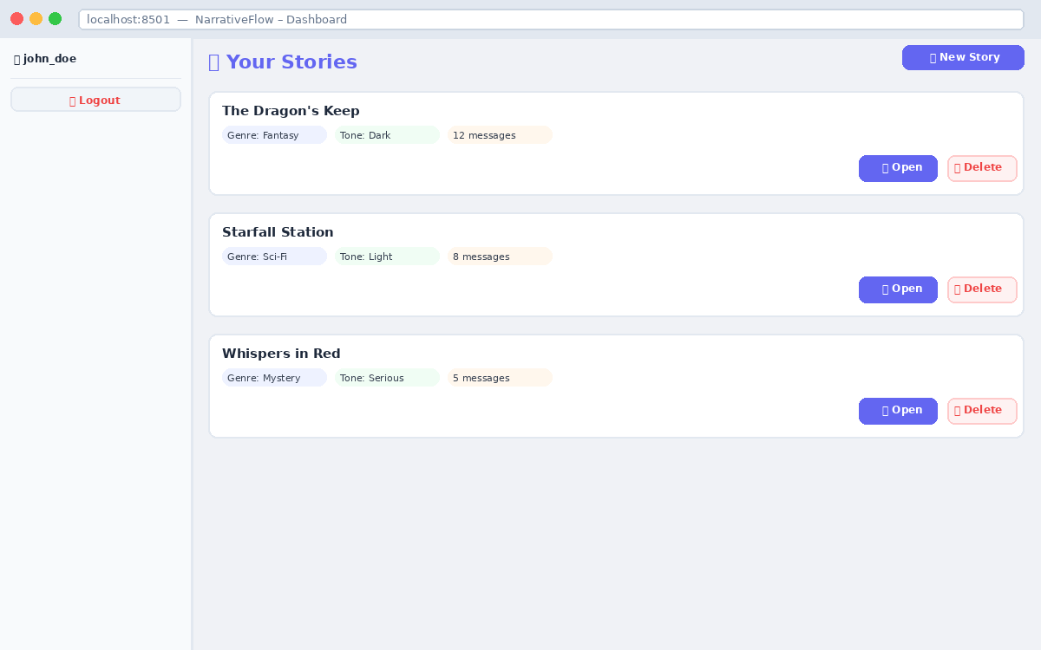
Figure 2 — Dashboard showing three saved stories
The Dashboard is the story management screen. All stories belonging to the logged-in user are loaded from SQLite and displayed as a vertical list of cards. A collapsible sidebar on the left shows the username and a Logout button.

Story Cards
Each card shows the story title, genre, tone, and message count. Two buttons sit to the right: Open takes the user into the Workspace, and Delete removes the story permanently from the database. Cards are separated by thin dividers to keep the list readable.
Creating a New Story
Clicking the '➕ New Story' button creates a new record in the database with default settings (Fantasy genre, Light tone) and immediately opens the Workspace. The title defaults to 'Untitled Story N' and can be changed at any time.
Empty State
When no stories exist yet, an informational message reads: '📖 No stories yet. Create your first story to begin!' This prevents the user from seeing a blank, confusing screen.

5. Screen 3 – Co-Writing Workspace
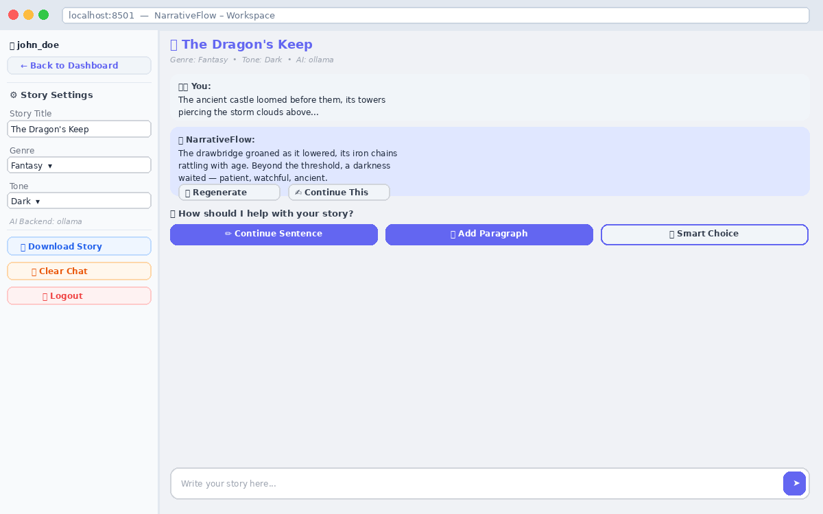
Figure 3 — Co-Writing Workspace with an active story session
The Workspace is the core feature. The screen is split into a settings sidebar and a main chat area. The user types story content into an input bar at the bottom, and the AI responds in a chat-bubble style above it.

Sidebar Controls
The sidebar contains story settings (title, genre, tone), an AI backend label, a Download Story button, Clear Chat, and Logout. The Download button only appears once the story has at least one message, preventing empty file exports.

Chat Messages
User messages appear in light grey bubbles labelled '🧑‍💻 You:'. AI responses appear in light indigo bubbles labelled '🤖 NarrativeFlow:'. Below the latest AI message, two action buttons are available — Regenerate (replaces the current response) and Continue This (appends a new AI response extending the existing one).

Co-Writing Modes
After the user submits text, three mode buttons appear. Continue Sentence completes an unfinished thought in one to two sentences. Add Paragraph writes a new story paragraph of three to five sentences. Smart Choice automatically detects whether the text is incomplete and picks the appropriate mode.

AI Prompt Design
Each mode sends a structured prompt to the AI that includes the story genre, tone, and the last five messages as context. This keeps responses consistent with what has already been written and avoids generic output.

Word Document Export
Clicking Download Story generates a .docx file in memory using python-docx. All messages are compiled into continuous prose. The file includes the story title, genre, tone, and a footer. The download triggers instantly in the browser.

6. Streamlit Integration
Streamlit was chosen because it allows building interactive web applications entirely in Python — no HTML, CSS, or JavaScript needed. This made it ideal for a rapid prototype focused on AI features and user experience.

How Streamlit Works in This Project
Streamlit re-executes the entire Python script on every user interaction. Session state (st.session_state) persists values — like authentication status, the current view, and the story list — between these reruns. After any state change, st.rerun() triggers a fresh render, which is how screen navigation is handled.

Key Components Used
- st.session_state — stores login status, current screen, and story data across reruns
- st.chat_input() — sticky input bar at the bottom of the Workspace for story text entry
- st.spinner() — loading overlay shown during every AI generation call
- st.download_button() — streams the in-memory .docx file directly to the browser
- st.tabs() — Login / Sign Up switcher on the Auth screen
- st.columns() — all multi-column layouts: form centering, story cards, mode buttons
- st.markdown(unsafe_allow_html=True) — custom HTML for styled chat bubbles
- st.sidebar — settings panel kept separate from the writing area

Limitations and Workarounds
Streamlit has no built-in routing, so screen navigation is handled through a current_view session variable. There is no native persistent storage, which is why SQLite was added via database.py. AI calls block the UI thread, which is masked using st.spinner(). Custom styling beyond Streamlit's defaults requires injecting CSS through st.markdown().

7. Errors Encountered
The following errors appeared during development. Each is listed with its cause.

StreamlitDuplicateWidgetID
Buttons inside a for-loop (story cards on the Dashboard) were all assigned the same default key, causing a crash. Streamlit requires every widget to have a unique key when rendered in a loop.
ModuleNotFoundError: No module named 'docx'
python-docx was not listed in requirements.txt initially, so running the app in a fresh environment failed immediately on import.
sqlite3.OperationalError: no such table
The database initialisation function init_db() was not being called before the first query ran. If the database file did not exist yet, every query failed.
Stories disappear on refresh
The original version stored stories only in st.session_state, which is wiped whenever the browser page reloads. There was no database persistence at all in the first version.
Fake authentication accepting any password
The original auth.py checked only whether the username and password fields were non-empty — it accepted any string as a valid login without comparing against any stored credentials.
Download file arrives as 0 bytes
After saving to a BytesIO buffer with doc.save(bio), the file pointer sat at the end of the buffer. Without calling bio.seek(0) to reset it, Streamlit streamed an empty file to the browser.
Ollama connection refused
The Ollama AI server must be running in a separate terminal before the app starts. When it was not running, the requests.post() call raised a ConnectionRefusedError with no user-friendly message.

8. Corrections Implemented
Every error above was resolved with a targeted code fix. Below are the corrections applied.

- DuplicateWidgetID — added f-string unique keys to all loop buttons: key=f'open_{story["id"]}'
- Missing module — added python-docx==1.1.0 and requests==2.31.0 to requirements.txt
- Table not found — added init_db() call inside init_session_state() in utils.py
- Stories lost on refresh — created database.py with SQLite CRUD functions; stories now saved after every create/delete
- Fake login — replaced the empty-string check with verify_login() which compares SHA-256 password hashes
- Empty download — added bio.seek(0) after doc.save(bio) in the export function
- Ollama crash — wrapped the API call in try/except; shows a readable error message if the server is offline
- None story crash — added a null-check at the top of show_workspace(): if not story: st.error(); return

Authentication: Before vs After
Version 1.0 accepted any non-empty username and password — there was no database check at all. Version 2.0 stores a SHA-256 hash of the password at sign-up and re-hashes the login input to compare. Sign-up also enforces a six-character minimum and blocks duplicate usernames at the database level.

9. Feedback and Improvements
Feedback was collected through self-testing, peer review, and mentor sessions during the internship. Each point was acted on.

Feedback Received

- "Stories disappear when I close the browser" → Fixed by adding SQLite persistence
- "Anyone can log in without a real password" → Fixed with hashed password authentication
- "AI responses are fake templates, not real AI" → Integrated Ollama, OpenAI, Claude, and HuggingFace backends
- "No feedback while the AI is thinking" → Added st.spinner() with descriptive labels on every call
- "Download button appears even with no content" → Hidden behind an if story['messages']: guard
- "Hard to tell which AI model is active" → Added AI Backend label to the sidebar
- "Clicking Delete doesn't persist after refresh" → Wired delete_story() to SQLite

Remaining Improvements for Future Version

- Auto-save messages to the database after every AI response
- Use bcrypt instead of SHA-256 for stronger password security
- Add email verification and a password reset flow
- Show a live word count in the sidebar while writing
- Allow story renaming directly from the Dashboard card

10. Learning Outcomes
Building NarrativeFlow end to end produced concrete learning across several technical areas.

Streamlit & Python
Learned how Streamlit's reactive re-render model works and how to manage state across reruns using st.session_state. Developed a modular Python project structure with clear separation between UI, data, and AI layers.
Database & Security
Implemented SQLite from scratch — creating tables, inserting and querying records, and handling integrity errors. Understood why plain-text password storage is dangerous and applied SHA-256 hashing as a practical improvement.
AI Integration
Learned how to call local LLMs via Ollama's REST API and cloud LLMs via the OpenAI and Anthropic SDKs. Understood prompt engineering — how including genre, tone, and conversation history in the prompt produces better, more contextual story continuations.
Debugging & Error Handling
Developed a systematic approach to debugging: read the full traceback, identify the line, understand the root cause, fix the cause rather than the symptom. Applied try/except blocks to all external calls (database, AI API) with user-friendly fallback messages.
Document Generation
Used python-docx to generate formatted Word files from in-memory data, including headings, paragraphs, alignment, and BytesIO streaming for browser download.

11. Overall Experience
The Infosys Virtual Internship provided a realistic, end-to-end software development experience. NarrativeFlow progressed from a rough idea to a working application with authentication, persistence, AI integration, and document export — all implemented by working through real problems.

What Went Well
- Streamlit enabled a fully functional multi-screen app with minimal setup code
- The chat-style interface felt natural for co-writing — user testing confirmed this
- Keeping each file focused on one responsibility made debugging fast and straightforward
- The configurable AI backend design means the app works free (Ollama) or with paid APIs
- python-docx produced clean, well-formatted Word documents with minimal code

Challenges
- Streamlit's stateless model required rethinking how navigation and persistence work
- Integrating multiple AI backends with different SDKs and error patterns took careful design
- The original authentication was a significant security gap that required a full rewrite
- Debugging silent failures (empty download, story not found) required careful tracing

Future Direction
The next phase of development would focus on cloud deployment so the app is accessible without a local install, richer text editing in the Workspace, auto-save after every AI response, and upgrading password storage to bcrypt for production security.

